British Sign Language (BSL) Plan

2024-2030

Contents

**Introduction 1**

**Review & Summary 7**

**GCC BSL Plan 11**

**Looking Forward 15**

# Introduction

This British Sign Language (BSL) Plan for Glasgow Clyde College as required by the BSL (Scotland) Act. It sets out actions we will take over the period 2024-2030.

It follows the BSL National Plan, published by the Scottish Government on 6th November 2023, which was developed through extensive engagement with deaf & deafblind BSL users* and those who work with them.

**Our second plan is framed around the same relevant goals as the national plan and the ten priority areas developed by the Scottish Government-**

1. Delivering the BSL National Plan 2023-2029

2. BSL Accessibility

3. Children, Young People and their Families

4. Access to Employment

5. Health and Wellbeing

6. Celebrating BSL Culture

7. BSL Data

8. Transport

9. Access to Justice

10. Democratic Participation

* Throughout the plan, we refer to ‘BSL users’. This covers all people whose first or preferred language is BSL, including those who receive the language in a tactile form due to sight loss. We understand that the majority of BSL users are deaf and deafblind, and that there are many deaf and deafblind people who do not use BSL. This plan will aim to be as inclusive as possible and support any deaf or deafblind person including those who may not solely use BSL.

As per the National Plan, Glasgow Clyde College’s BSL Plan includes strategic priorities as long term aims. To ensure that we achieve our goals by 2030, the College will produce and develop a SMART action plan, with a mix ofshort-, mid- and long-term actions that will be delivered in the six-year life of this plan. We will also continue to engage with and involve external organisations and experts from some of the following organisations-

Action on Hearing Loss <https://www.actiononhearingloss.org.uk/>

British Deaf Association <https://bda.org.uk/>

British Sign Language [British Sign Language (BSL): national plan 2023 to 2029 - gov.scot (www.gov.scot)](https://www.gov.scot/publications/bsl-national-plan-2023-2029/)

Contact Scotland [contactSCOTLAND-BSL](http://contactscotland-bsl.org/).org

Deaf Action <http://www.deafaction.org.uk/>

Deaf Connections <https://www.deafconnections.org/>

Deafblind UK <https://deafblind.org.uk/>

National Deaf Children’s Society <http://www.ndcs.org.uk/>

Scottish Association of Sign Language Interpreters (SASLI) <http://www.sasli.org.uk/>

[Scottish Sensory Centre](http://www.ssc.education.ed.ac.uk/)

Sign Language Interactions [Home - (signlanguageinteractions.com)](https://signlanguageinteractions.com/?utm_source=google&utm_medium=cpc&utm_campaign=11038515794&utm_content=113834267968&utm_term=sign%20language%20interactions&gad_source=1&gclid=Cj0KCQjw2a6wBhCVARIsABPeH1shsKgC50GUymUqAFcZ36uFjIundCh8YrUQ6GUK3qzw8kdbTrVaS_EaAufaEALw_wcB)

**College Values**

Our BSL Plan supports our College values. We are a people-centred community and an unrivalled student experience and sense of belonging is at the heart of everything we do.

We seek to promote and embed the principles of equity, accessibility and inclusion in all College services and in every aspect of College life.

Our College values are at the forefront of everything we do and are incorporated into strategic and operational plans, including this BSL plan, at all levels across the College.

Our College Values are People-centred, Pioneering, Principled and Passionate.

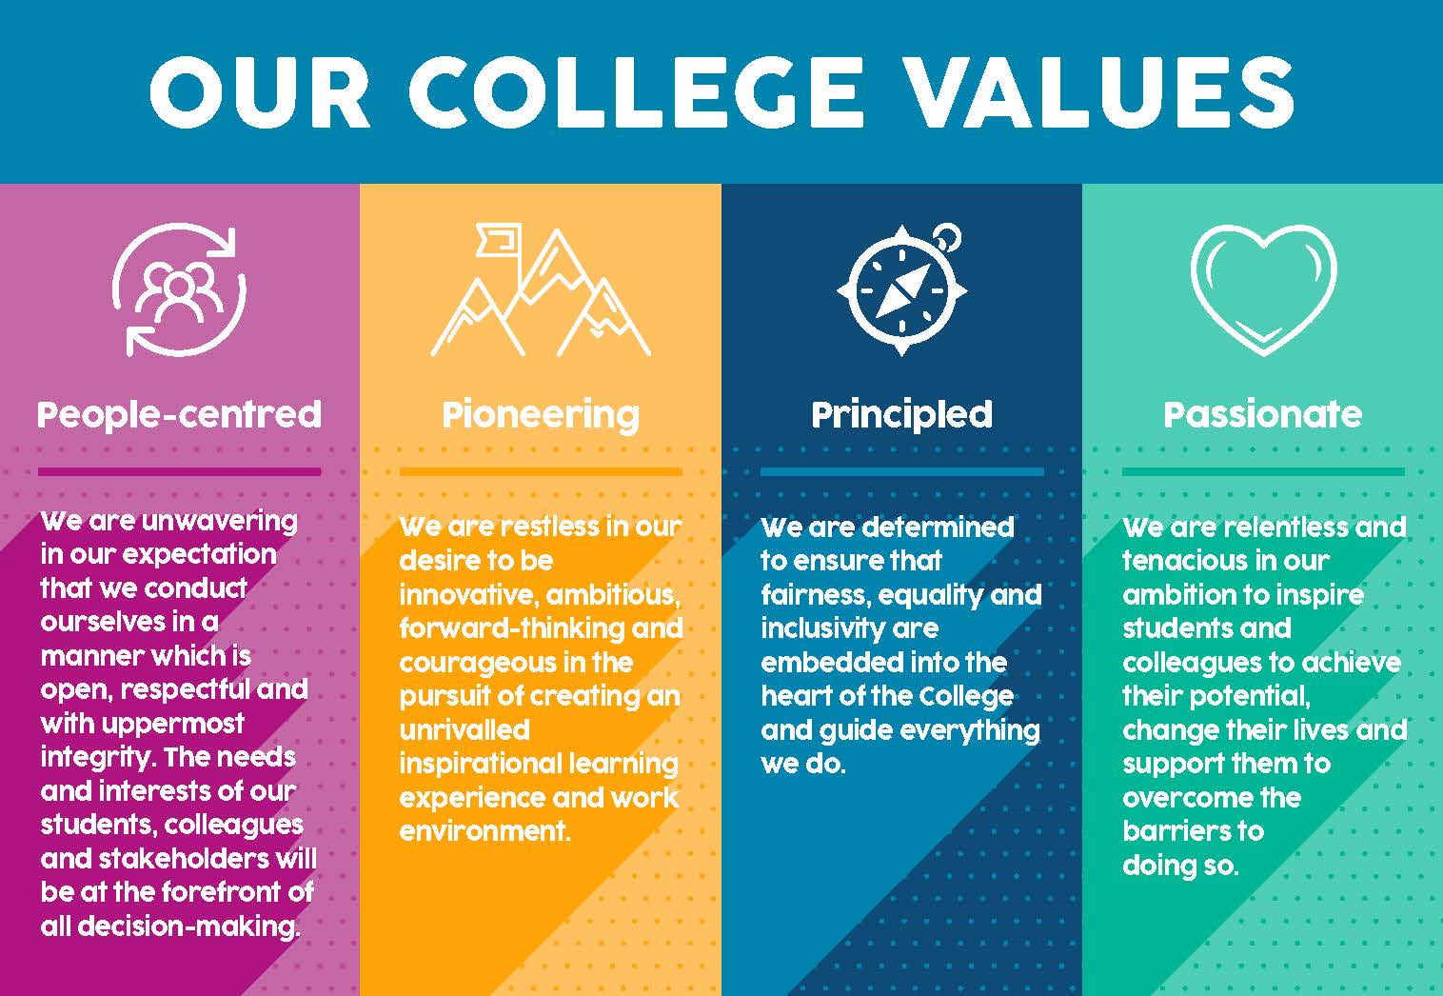

In constructing our BSL plan, we considered the requirements of a range of internal and external stakeholders including the strategic priorities of the Scottish Government, together with our plans and values, and the needs and aspirations of our College community.

Glasgow Clyde College is an active participating member of the FE & HE Sector BSL Group. This group has met regularly since 2023 and comprises of staff from most of the Universities & Colleges in Scotland including representation from BSL users, and engagement with Scottish Government BSL Policy Manager.

# Review & Summary

Since our BSL Plan review in 2020, we have achieved the following-

**Curriculum**

A successful collaboration with the [Scottish Ethnic Minority Deaf Charity](https://semdc.org.uk/) in 2024. This partnership allows us to offer a course in ESOL (English for Speakers of Other Languages) and Numeracy to a group of Deaf international learners, taught entirely through Sign Language.

We offer [SQA BSL (BRITISH SIGN LANGUAGEL) LEVEL 1 (glasgowclyde.ac.uk)](https://www.glasgowclyde.ac.uk/courses/2027077-sqa-bsl-british-sign-language-level-1/5046)

**BSL & Deaf Awareness training**

Use of contact Scotland has been promoted with instructions for use to all staff and is embedded within all staff signature strips. ***cid:image019.png@01D5A46D.50206AF0***

2020 - 2021 3 separate sessions of Deaf Awareness Training plus a session for Including Students who are Deaf, Visually Impaired or Deafblind

2022-2023 Deaf Blind Scotland Seminar

2022-2023 Introduction to Child Deafness

Planned Training- Deaf Awareness sessions in June & August 2024

On average about 70 staff are trained annually in Deaf Awareness or other relevant training.

Majority of Learning Inclusion Advisers have completed basic BSL training. 3 x Advisers with CACDP BSL Level 1 & 2. Five out of our seven Student Information & Welfare team have had BSL training at different levels. The team are looking to refresh and ensure that everyone has completes appropriate and relevant training.

We have a BSL Introductory course available on our VLE for staff and students and will monitor and review the course and its usage over the course of the plan.

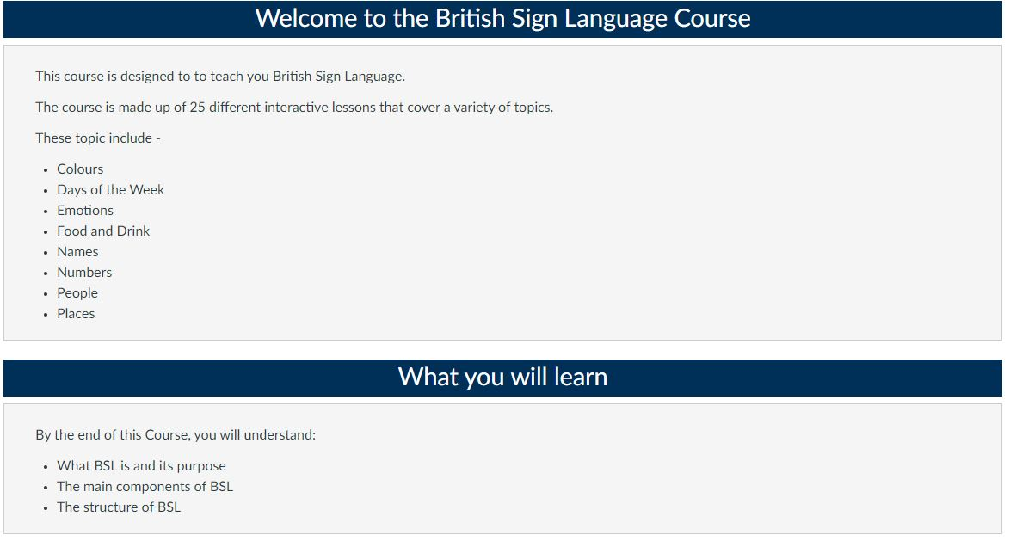

**Supporting BSL users – Learning Inclusion**

The Learning Inclusion (LI) team are involved in supporting BSL users from the interview/event invitation stage of the application process. On informing the LI team that they are a BSL user and require support, the College arranges all necessary help and interpreters.

We currently use a mix of staff employed by the College, self-employed BSL users and [Sign Language Interactions](https://signlanguageinteractions.com/?utm_source=google&utm_medium=cpc&utm_campaign=11038515794&utm_content=113834267968&utm_term=sign%20language%20interactions&gad_source=1&gclid=Cj0KCQjw2a6wBhCVARIsABPeH1tTcYR0NjW-M2pXEDPJYMsYF578_AYo5dBh0xS40pREUIBu1RRdccYaAsGKEALw_wcB)

**Total number of BSL students supported by LI**

2020/21 – 3 2021/22 – 2 2022/23 – 1 2023/24 – 5

**Website/Online Accessibility**

In 2023 we conducted a full Accessibility Audit of the College website in conjunction with the Accessibility Monitoring Team within the UK Government Cabinet Office. We identified 21 pages of improvement opportunities containing 56 recommendations of which we were able to fix 52 issues.

All videos across social media and the College website include subtitles.

**BSL Working Group**

Over the past three years, we have experienced a decline in enrolment for our full-time BSL Studies courses, faced staffing challenges within the BSL programme and across the College that has led to restructuring and higher than average staff turnover.

Due to both funding constraints and staffing limitations, our original Working Group disbanded and our ability to organise other BSL-related activities within the College were restricted.

However, we now have a new BSL Working Group chaired by the Equality & Diversity Lead. The membership includes staff from across the College -

Assistant Principal, Head of Inclusion, Info & Welfare, Curriculum Quality Lead, Glasgow Clyde College Student Association (GCCSA) Coordinator, Student Info & Welfare, Learning Inclusion, Organisational Development, HR, Elearning, Marketing, Library Coordinator, Nurseries, plus engagement with external organisations and BSL users within our College community.

In order to underline our commitment, this group will meet at least twice a year to review, develop and progress the College’s local SMART action plan, underpinning our BSL work over the next 6 years. The BSL Working Group’s progress will remain a standing agenda item on the College’s strategic Equality & Diversity Committee that reports directly to the Senior Leadership Team.

If you wish to contact the BSL Working Group, please email [equality@glasgowclyde.ac.uk](mailto:equality@glasgowclyde.ac.uk)

The BSL version of the College’s BSL plan can be accessed at the relevant link on our [College website.](https://www.glasgowclyde.ac.uk/)

**Summary**

This British Sign Language (BSL) Plan sets out the actions that we at Glasgow Clyde College will undertake from 2024 to 2030 in order to support and achieve the relevant goals as set out by the Scottish Government’s National Plan.

The key principles of the BSL Plan are:

1. Making Glasgow Clyde more accessible by addressing identified issues and challenges for BSL users and deaf/deafblind people who study, work and visit the College
2. Finding approaches to enhance the quality of our provision for deaf/deafblind people.
3. Identifying any additional policy or guidance areas required to support deaf/deafblind students, staff and visitors
4. Providing an inclusive learning and working environment to meet the needs of the individuals and communities it serves.
5. Raising awareness and increasing relevant training and development opportunities for staff

The actions included within this plan will be underpinned by a SMART action plan, mapped against our key principles and monitored by the College’s BSL Working Group. This confirms our commitment to ensure that all BSL users be they students, staff or other stakeholders are fully supported and are part of our inclusive and welcoming College community, where everyone feels a sense of belonging.

We will continually engage with and respond to BSL users’ views to develop our key actions within our plan to ensure better services and inform best practice.

Our goals in this plan are long term, however the local SMART plan will contain specific short, medium or long term aims. Timescales for each are as follows-

Short- up to 1 year, Medium- up to 3 years & Long- up to 6 years

# Glasgow Clyde College BSL Plan

1. **Delivering our Glasgow Clyde College BSL Plan 2024-2030**

Establish GCC BSL plan in accordance with Scottish Government’s National BSL Plan.

Re-establish our BSL Working Group to monitor and develop our SMART action plan underpinning this BSL Plan.

Remain a member of the FE & HE BSL Group

Ensure compliance with the new Inclusive Communication duties included in the Scottish Public Sector Equality Duties 2025

Publish a midpoint review of this plan as per Scottish Government requirements

1. **Accessibility**

Continue to include Contact Scotland details and logo in all staff signature strips and highlight their services to all staff.

Publish our BSL Plan on our website, fully captioned and translated. Include the College Working Group details and local SMART Plan are available to all staff with access to students via the Glasgow Clyde College Student Association.

Identify, prioritise and improve specific services/information and include more BSL video content across the College

Audit our BSL accessibility

1. **Children, Young People and their Families**

The Getting it Right for Every Child (GIRFEC) approach will be fully embedded to support all BSL users.

Develop an internal GCC SMART action plan to sit behind the published plan to ensure actions are developed and implemented across the College

Provide fully accessible and inclusive information, guidance and support for students and prospective students throughout their learner journey

All relevant support provided during transition process to and from College

Fully support transition from school/community groups to GCC for BSL users and their families

Establish direct links and appropriate partnership working with specialist school provision

Fully inclusive and accessible application and interview process

College nurseries will provide a service that is both accessible and inclusive for all.

Integrate awareness and promotion of BSL with all children and their families

Provide BSL and Deaf Awareness training to all staff

Relevant HR policies for staff will be fully accessible and inclusive for BSL users

Continued collaboration with regional partners and external organisations to ensure good practice

Prioritise analysis of feedback from BSL users across our services

1. **Access to Employment**

New College Careers Service meets the needs of all individuals ensuring appropriate specific support for BSL users

Expand provision of BSL related courses

GCC staff recruitment process is fully accessible

Raise profile of the College as an inclusive employer

1. **Health and Wellbeing**

Identify and ensure all relevant College services are fully accessible to BSL users, including

Counselling, Health & Safety, First Aiders & Mental Health First Aiders, Mental Health College Services, GBV (Gender Based Violence) support and reporting tool, Safeguarding and HR

1. **Celebrating BSL Culture**

Review and include BSL support & provision in the planning and delivery of student/staff events/activities.

Raise awareness around BSL culture including celebrating BSL Day annually

Encourage staff to train/raise awareness

Enable and encourage BSL users to take part in culture and the arts as participants, audience members and professionals

1. **BSL Data**

Improve data gathering and performance indicators for BSL Users and deaf students

Improve data, identify and prioritise relevant staff training and provide to key staff

Identify and progress transition to/from College data

Analyse all relevant data and surveys to identify key information gaps and measure progress to improve services and increase BSL content

Gather and share data with regional and national partners to advance equality

Embed new public sector equality duty regarding Inclusive Communication

1. **Transport**

Identify and review specific requirements of BSL users regarding access to transport, to and from the College

1. **Access to Justice**

Signpost and raise awareness of relevant national bodies, organisations and interpreting services to BSL users

Ensure all College reporting procedures are fully accessible and inclusive including Complaints, Grievance, GBV (Gender Based Violence) and Safeguarding reporting.

BSL users can fully access and participate in all College surveys and questionnaires

1. **Democratic Participation**

Encourage and enable BSL users to take an active and full role in working groups, committees and structures of the College

The student association will ensure BSL users can fully engage in all our democratic structures, including Class Rep and GCCSA officer elections.

# Looking Forward

We look forward to the Scottish Government’s new Inclusive Communication regulation due to come into force as part of the Public Sector Equality Duty (PSED) in April 2025. This will further enhance our work towards more accessible and inclusive services.

The BSL Working Group will create the SMART action plan and review our BSL plan every 6 months, reporting directly to the Equality, Diversity & Inclusion Committee

We welcome feedback on our BSL Plan, whether you are part of a group, or are an individual, we are happy to for you to get in touch and provide us with your views.

You can comment on this plan or if you wish to be involved as we further develop/implement the actions in our plan, please contact us via the relevant [Contact Us](https://www.glasgowclyde.ac.uk/contact-us) link on our [website](https://www.glasgowclyde.ac.uk/) using written English and /or upload BSL video clips to respond or email [equality@glasgowclyde.ac.uk](mailto:equality@glasgowclyde.ac.uk)

The final version of the plan is available in BSL, as a Word document or in PDF on our [website](https://www.glasgowclyde.ac.uk/).